Experiment: Implementation of A Search Algorithm*
Aim
To implement the A* (A-Star) Search Algorithm in Python to find the shortest path from a start node to a goal node using path cost and heuristic values.

Objectives
- To understand the working of the A* search algorithm.
- To find the optimal path between the source and destination.
- To use heuristic values to improve search efficiency.
- To compare the path cost and estimated cost during the search.
- To implement A* using Python.

Algorithm
Step 1: Start.
Step 2: Initialize the graph and heuristic values.
Step 3: Create an Open List (priority queue) and insert the start node.
Step 4: Set the cost of the start node g = 0.
Step 5: Calculate the evaluation function:
where:
- g(n) = Actual cost from the start node.
- h(n) = Heuristic estimate to the goal.
- f(n) = Total estimated cost.
Step 6: Remove the node with the smallest f(n) value.
Step 7: If the current node is the goal node:
- Display the shortest path.
- Display the total cost.
- Stop.
Step 8: Otherwise, expand all neigh boring nodes.
Step 9: Update the cost and parent if a shorter path is found.
Step 10: Insert the updated nodes into the Open List.
Step 11: Repeat Steps 6–10 until the goal is reached or the Open List becomes empty.
Step 12: Stop.

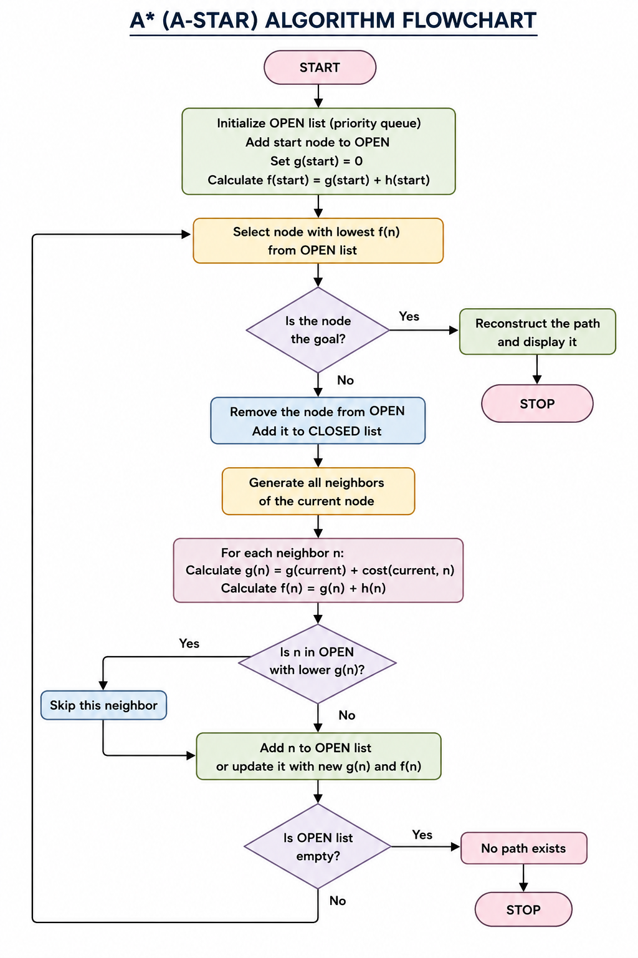
Source Code
# A* Algorithm Implementation in Python

# Graph representation
graph = {
'A': [('B', 1), ('C', 3)],
'B': [('D', 3), ('E', 1)],
'C': [('F', 5)],
'D': [('G', 2)],
'E': [('G', 4)],
'F': [('G', 2)],
'G': []
}

# Heuristic values (estimated cost to goal)
h = {
'A': 6,
'B': 4,
'C': 5,
'D': 2,
'E': 3,
'F': 2,
'G': 0
}

def a_star(start, goal):
open_list = [start]
closed_list = []

g_cost = {start: 0}
parent = {start: None}

while open_list:

# Select node with lowest f(n) = g(n) + h(n)
current = min(open_list, key=lambda x: g_cost[x] + h[x])

print("Current Node:", current)

if current == goal:
path = []
while current:
path.append(current)
current = parent[current]

return path[::-1]

open_list.remove(current)
closed_list.append(current)

for neighbour, cost in graph[current]:

if neighbour in closed_list:
continue

new_g = g_cost[current] + cost

if neighbour not in open_list:
open_list.append(neighbour)

if neighbour not in g_cost or new_g < g_cost[neighbour]:
g_cost[neighbour] = new_g
parent[neighbour] = current

return None

# Starting and goal nodes
start_node = 'A'
goal_node = 'G'

result = a_star(start_node, goal_node)

print("\nOptimal Path:")
print(" -> ".join(result))

OUTPUT
